***Name-Sahil Javiya***

***Roll No.- AF0407785***

***Batch Code-ANP-C8231***

***Lab 1***

1.Write a Java program to print "Hello, World!" to the console.

Input-

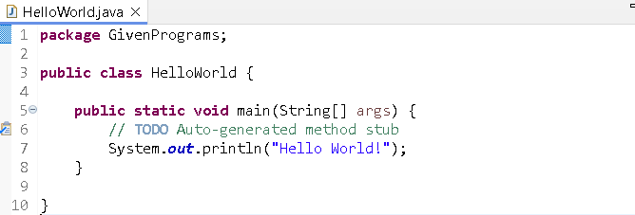

Output-

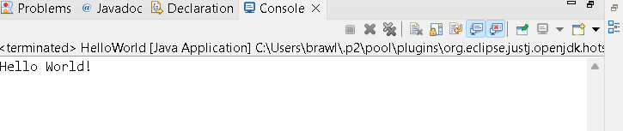

2.Write a program to find the sum of two numbers entered by the user.

Input-

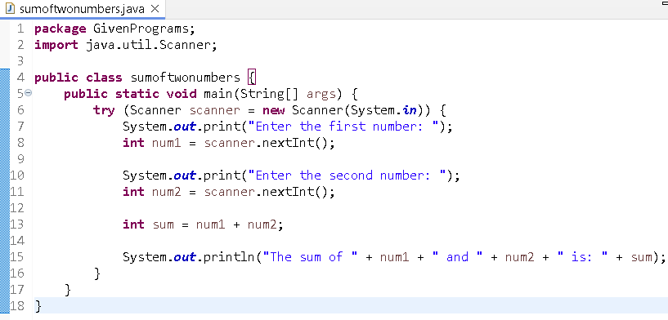

Output-

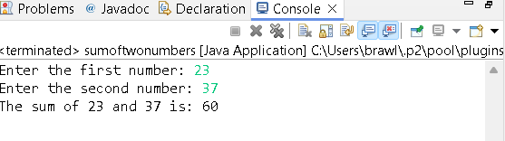

3.Write a Java program to check whether a given number is even or odd.

Input-

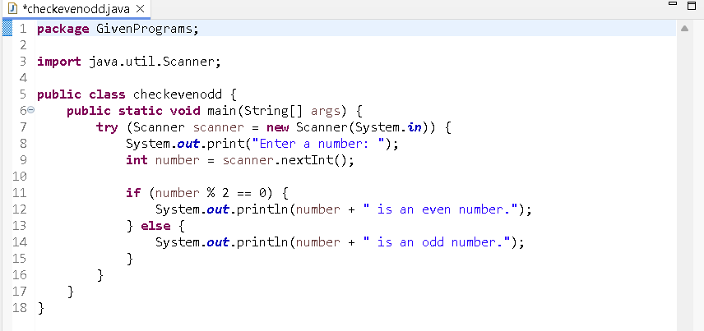

Output-

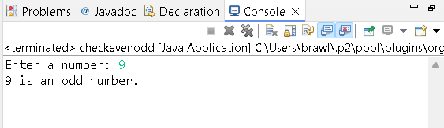

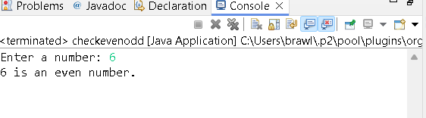

4.Write a java program to find greatest of 2 numbers.

Input-

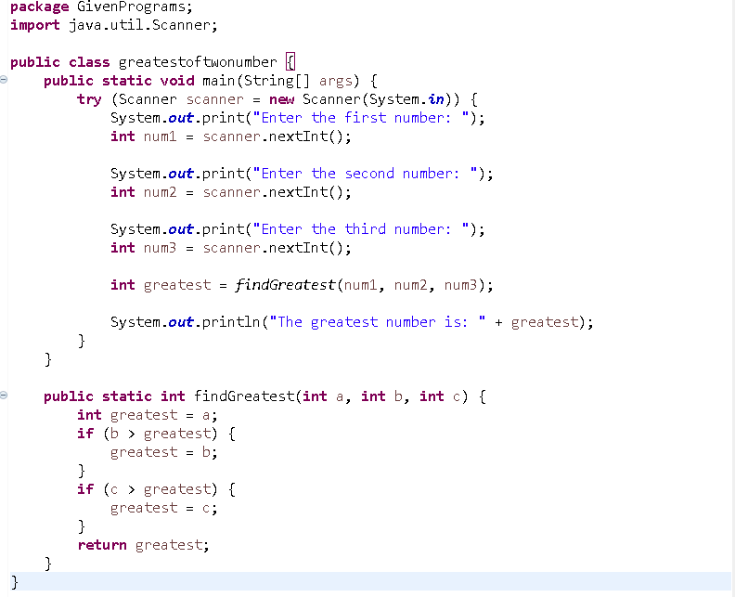

Output-

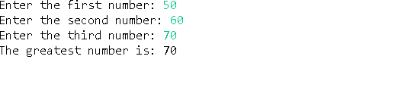

5.Write a program to implement a basic calculator that takes input and evaluates it.

Input-

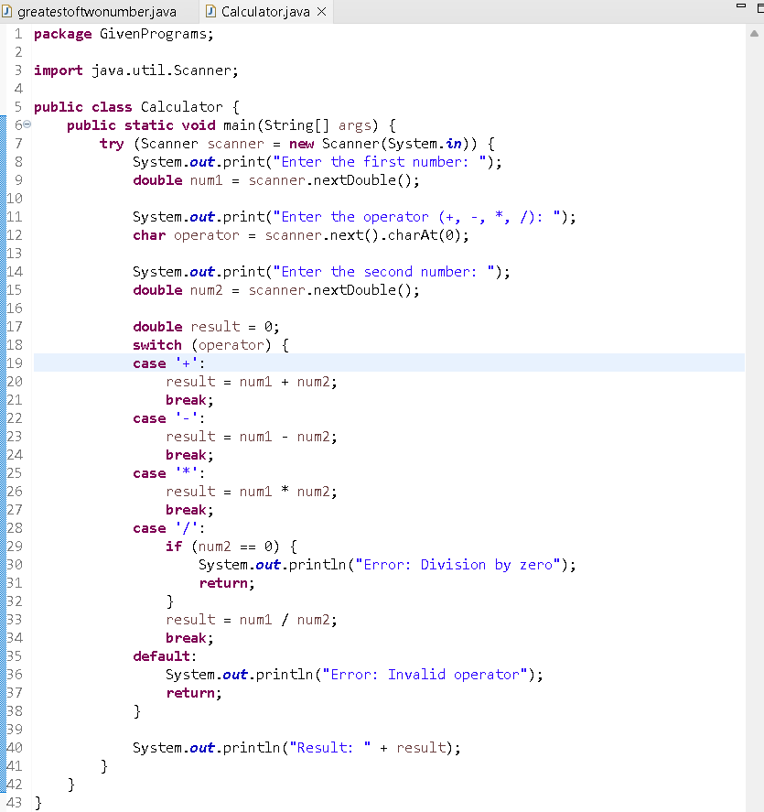Output -

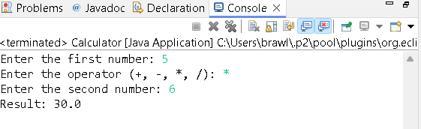

6.Write a Java program to check if a given number is prime or not.

Input-

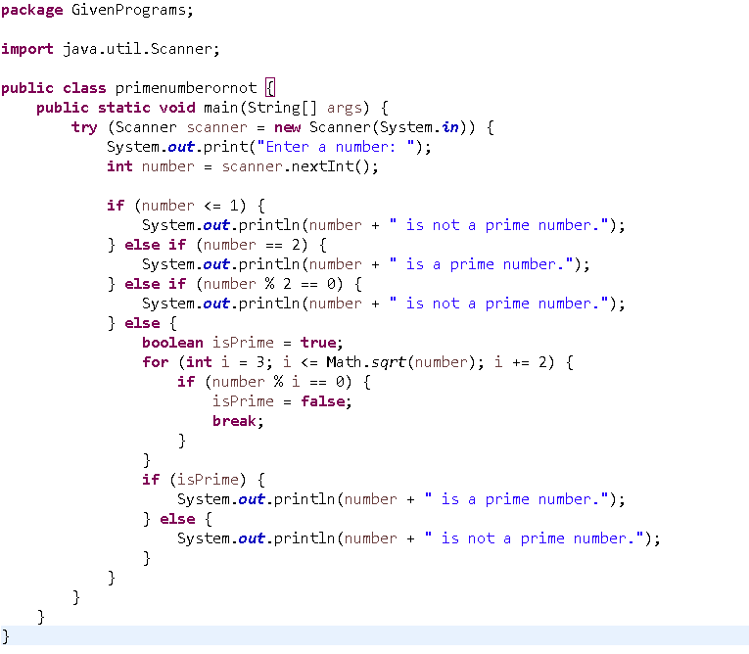

Output-

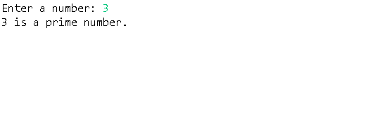

7.Create a Java program that compares two numbers and prints the larger one.

Input-

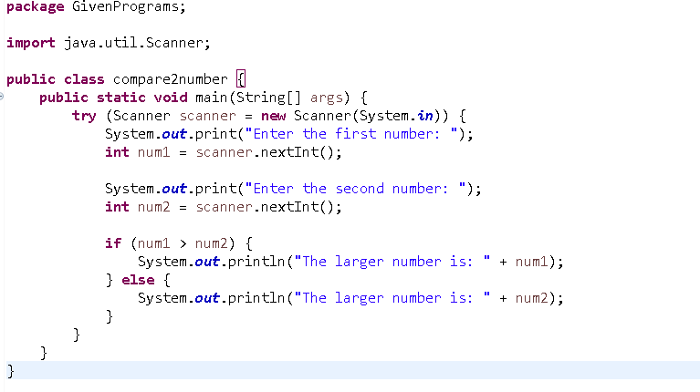

Output-

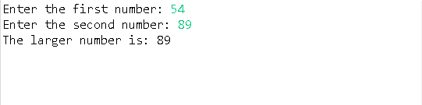

8.Write a Java program that takes an age input from the user and determines if they are eligible to vote (considering the legal voting age).

Input-

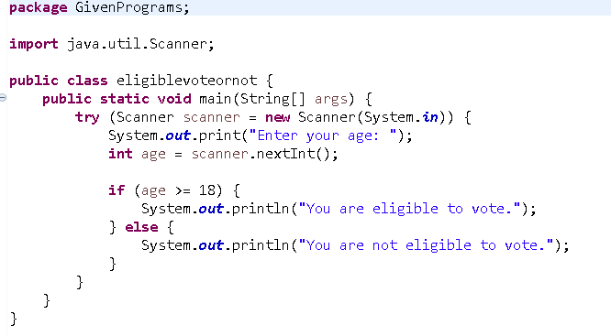

Output-

